SAFE MATERIAL HANDLING

SAFE WORK GUIDELINES
The following information is intended to encourage safe material handling while on assignment at a customer site and supports the Kelly Health & Safety Policy and our goal of Absolute Zero.

Back injuries are the most common of all industry related injuries. These injuries are often caused by the use of improper lifting techniques during material handling. This guide demonstrates an overview of how-to safety lift, move and carry objects.

Principles of Lifting
Lifting of any kind poses a potential risk of injury. From the lightest load to the heaviest, lifting an incorrect way can cause injury. When lifting, there is a lot to consider.

Considerations when Lifting
Load:
- Weight
- Size
- Shape
- Handles
- Slippery surface

The Task itself:
- Distance load is to be carried
- Postures (e.g., twisting, bending, reaching)
- Repetitiveness of task
- Position of load (e.g., height too high, too low)
- Multiple handling (e.g., lifting, carrying, loading)

Environmental:
- Floor surfaces (e.g., slippery, uneven or damaged)
- Distractions (e.g., noise, lighting, co-workers)
- Time constraints
- Temperature
- Obstacles

Human Characteristics:
- Physical factors (e.g., height, weight, strength, flexibility)
- General health
- Pre-existing musculoskeletal conditions
- Motivation
- Stress

When given the task of lifting, we will seldom take into consideration all the above before we lift an object. Knowledge is the key to successful lifting. By understanding all of the considerations involved in lifting we can be better prepared before starting the task of lifting, thus eliminating the risk factors involved.

A Safe Lift
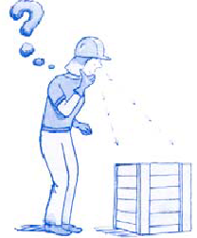
A safe lift starts with sizing up your load. A quick glance will help you determine size, shape and surface. By simply placing a hand on the box and tilting or sliding the object, you will be able to roughly determine the weight. Also observe the area in which you have to lift. Small spaces may require more twisting to manoeuvre with the object.

Note: Never blindly lift an object without determining the weight beforehand.

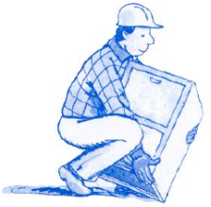
- Start with having your feet shoulder length apart with the load between them.
- Bend at the knees keeping your back relatively straight.
- Ensure you have a firm grip on the load.
- Lift slowly with your thigh and leg muscles, not your back.
- Keep arms and elbows close to your sides
- Keep the load close to your body.

Carrying a Load
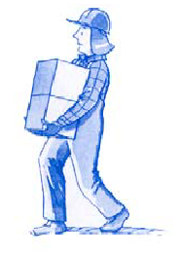
The way we carry a load is just as important as the way we lift it. Safe carrying of a load starts with these factors:

- Before carrying a load, ensure your path is clear of obstacles that may cause you to trip
- Keep the load close to your body
- Keep a firm grip on the load
- Keep load at a height that you can clearly see where you’re going

Handling a Load
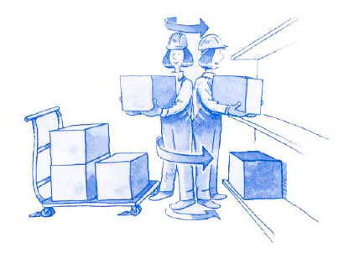
If the load we are handling is heavy, we tend to cut corners to get the job done quickly. This results in incorrect bodily motion which may cause injury. Always remember these procedures.

- Avoid twisting and turning while carrying a load
- Keep the load in front of you
- Never rotate at the waist
- Pivot with your feet
- Don’t twist your back to move a load

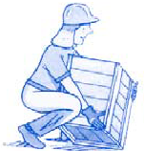
When lowering a load, reverse the lifting procedure.

- Keep the load close to your body
- Keep a good grip on the load
- Bend with the knees, not your back
- Lower the load slowly
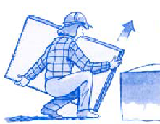
Lifting objects that are awkward, heavy or hard to reach require extra considerations.

- Test the weight and shape of an object
- Can it be lifted alone?
- Follow proper lifting procedures.
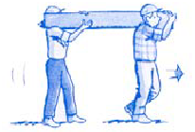
- Ask for help

- If the weight of an object exceeds the Kelly limit of 25lbs, ask for help.
- Never attempt to lift a load that is too heavy.
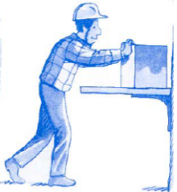

- If a load is too high, use a stool or platform.
- Slide the load toward you first.
- Test the weight and lift properly.

Controls:
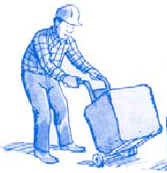
A control is any precaution, safeguard, protective device, guard or lifting device that’s designed to protect the worker. Controls are meant to eliminate the risk of bodily harm. Where applicable and available, always use a lifting device instead of lifting yourself.

If a lifting device is available, ensure that you understand the hazards involved in its use and you have received training on its proper handling.

Responsibility
The Safety Department is the designated owner of this work instruction and is responsible for the content as well as for ensuring that the document is updated as required.

The branch is responsible for reviewing the available documentation and conducting any safety assessments or inspections as necessary.

Contacts
- Holly Hardison, Safety, Health & Environmental Manager, +1 226 759 5839
- Cheri Duggan, Global Senior Safety, Health & Environmental Manager, +1 661 204 2959

